User Journey Tool Mock Data

This WIP document is intended to provide a description of the mock data for the UJT. By providing a standard, we can more easily test and discuss the project with a concrete model, instead of relying on abstract concepts.

The system design is loosely modeled from the [Art of SLOs](https://static.googleusercontent.com/media/landing.google.com/en//sre/static/pdf/art-of-slos-handbook-a4.pdf) handbook (p. 18). I also chose not to use a system based on Photos or to design a Photos-like service to avoid confusion, as the mock data model would not be suited to capture all the nuances of the existing system. This way, we can discuss the tool with a fixed dataset while not conflating components with existing systems.

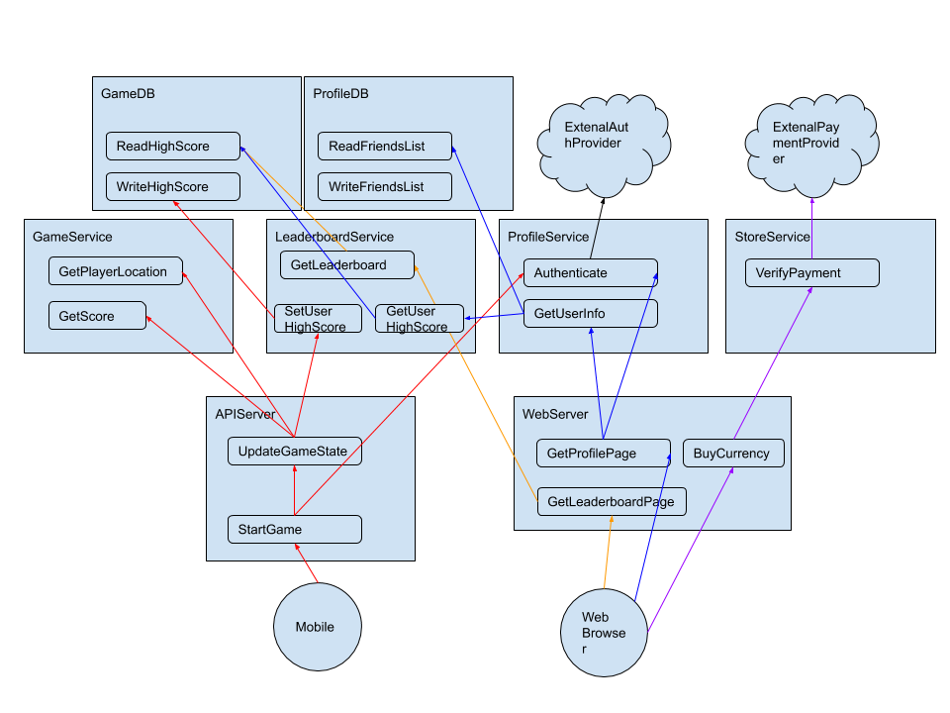

Example protos:

|  |  |
| --- | --- |
| File | Contents |
| Client_MobileClient | name: "MobileClient"  user_journeys {  name: "Play a Game"  dependencies {  target_service_name: "APIServer"  target_endpoint_name: "StartGame"  }  } |
| Client_WebBrowser | name: "WebBrowser"  user_journeys {  name: "View Leaderboard"  dependencies {  target_service_name: "WebServer"  target_endpoint_name: "ViewLeaderboard"  }  }  user_journeys {  name: "View Profile"  dependencies {  target_service_name: "WebServer"  target_endpoint_name: "ViewProfile"  }  }  user_journeys {  name: "Conduct Microtransaction"  dependencies {  target_service_name: "WebServer"  target_endpoint_name: "BuyCurrency"  }  } |
| Node_APIServer | node_type: NODETYPE_SERVICE  name: "APIServer"  child_names: "APIServer.StartGame"  child_names: "APIServer.UpdateGameState"  slis {  node_name: "APIServer"  sli_value: 0.13741996301464876  slo_error_upper_bound: 0.9  slo_error_lower_bound: 0.1  slo_warn_upper_bound: 0.8  slo_warn_lower_bound: 0.2  } |
| Node_APIServer.StartGame | node_type: NODETYPE_ENDPOINT  name: "APIServer.StartGame"  parent_name: "APIServer"  dependencies {  target_name: "APIServer.UpdateGameState"  source_name: "APIServer.StartGame"  }  slis {  node_name: "APIServer.StartGame"  sli_value: 0.10371840129755339  slo_error_upper_bound: 0.9  slo_error_lower_bound: 0.1  slo_warn_upper_bound: 0.8  slo_warn_lower_bound: 0.2  } |